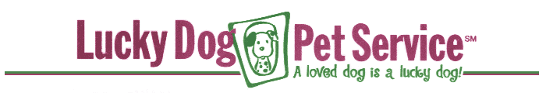
CUSTOMER CONTRACT
This contract is an agreement between Lucky Dog Pet Service, Inc. and ________________________ (Customer) for pet care services beginning on _______________, and thereafter on an as-needed basis.
Lucky Dog Pet Service agrees to provide pet care services in a reliable, trustworthy and caring manner. I (Customer) agree to the following:
PET CARE
- If my pet(s) become ill while under the care of Lucky Dog, I authorize Lucky Dog to transport my pet(s) to my veterinarian (or one who is available) if this is needed. I authorize Lucky Dog to approve any emergency treatment recommended by the veterinarian and I agree to pay promptly for any vet bills thereby incurred. I release Lucky Dog from all liabilities related to the transportation, treatment, and expense of caring for my pet(s).
- I agree to reimburse Lucky Dog for any expenses incurred by Lucky Dog in providing care to my pet(s), including but not limited to any unexpected supply needs.
PAYMENT
- I understand that Lucky Dog daycare payments must be made in advance of or at time of service.
- I understand that when I purchase a daycare pass, there are no refunds or credits given and that it is my responsibility to use the pass within the specified number of days before the pass expires.
- I agree that if I do not cancel a reservation before 5 pm the previous day, I will be charged for the reservation.
- I understand that payment for boarding must be made at time of pick-up. I understand that my pet(s) may not be released from the premises until all charges are paid in full.
- I authorize Lucky Dog to charge my credit card account for any outstanding invoices.
- I understand that if the unpaid balance remains unpaid for 60 days or more, unless other arrangements are made, my Lucky Dog account will be turned over to a collection agency and that as a result I will be liable for collection costs and attorney fees in addition to the unpaid balance.
- I understand that I will be charged a $20 handling fee for checks returned for any reason.
- I understand that Lucky Dog may require customers with a history of late payment to pay the full amount in advance before services are rendered.
LIABILITY
- I understand that if my pet(s) has a history of biting or aggression, Lucky Dog reserves the right to refuse service, and that all bits will be reported to the local authorities as provided by law.
- I understand that the Lucky Dog daycare is a free-run facility. I accept the risks involved and agree that Lucky Dog is not liable for any injuries or illnesses resulting during my dog's attendance.
- I agree to pay any medical care expenses and damages that result from injuries caused by my pet(s).
- I expressly waive and relinquish any and all claims against Lucky Dog, its employees and representatives, except those arising from gross negligence on the part of Lucky Dog.
- I understand that under no circumstances will Lucky Dog be liable for consequential damages or damages beyond the replacement value of my pet(s).
FUTURE SERVICES
I authorize this contract to be valid approval for future services so as to permit Lucky Dog to accept my telephone reservations without additional signed contracts or written authorizations.
Customer___________________________________________________ Date______________________

